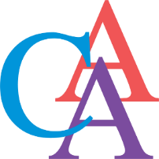
Cromwell Arts Alliance
MEETING
Monday, February 13, 2023
6:00 pm
Senior Center Dining Room (at Cromwell Town Hall)
Join virtually:
Join Zoom Meeting via your computer:
https://atlanticdatasecurity.zoom.us/j/99802619219
Password: 990451
Join Zoom Meeting via phone:
Phone number: 1 646 558-8656
Meeting ID: 998 0261 9219
Password: 990451

Meeting Agenda

- Call to order
- Approval of agenda
- Approval of minutes from the meeting on January 9, 2023
- Public comments
- Financial report
- All other business
  - CCD Report
  - Social Media/website
- CAA Events
  - Photo Contest display at Town Hall
  - Recap Poetry Event
  - Traveling Bear Update
  - Others
- Community Events
  - Re-establish a connect with the schools
  - Middle & High School play donation
  - Upcoming Events
- Public Comments – agenda items only
- Adjourn

2023 Meeting Dates:
Meetings are held on the Second Monday of the month (unless it is a holiday) at 6:00 pm. We will continue to meet in person in the Senior Center Dining Room (at Cromwell Town Hall), we will also continue to have an open zoom conference for those wishing to join virtually.
January 9 | April 10 | July 10 | * Tuesday October 10
February 13 | May 8 | August 14 | November 13
March 13 | June 12 | September 11 | December 11
*Meeting held on Tuesday due to Holiday

