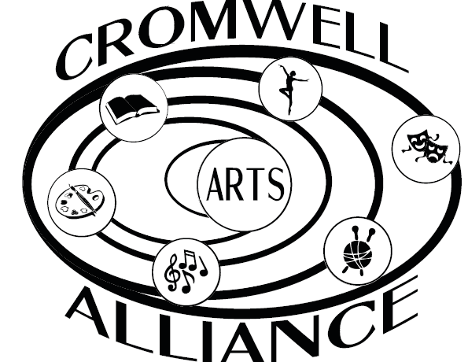CROMWELL ARTS ALLIANCE LOGO WEAR!

Ladies Relaxed V-Neck Tee/Royal Blue Logo on Chest “Pocket” $15
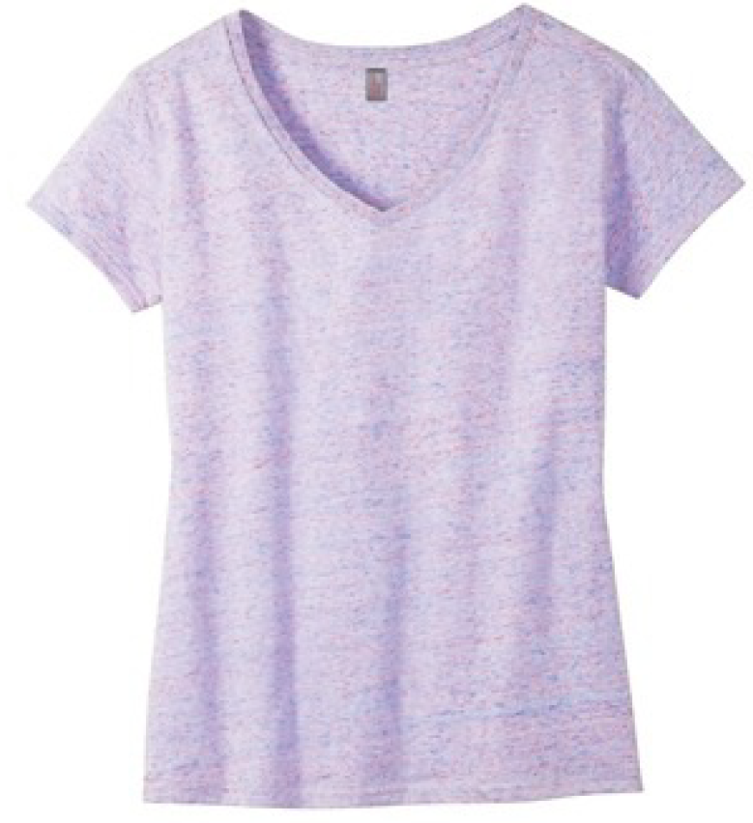Available In: 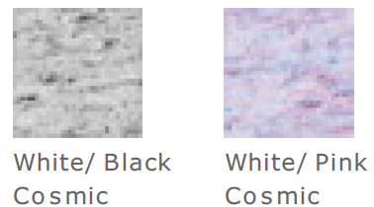
XS S M L XL XXL (add $2)
Quantity: ____ ____ ____ _____ ____ ____
Color: ____ ____ ____ _____ ____ ____
Total: ____ ____ ____ _____ ____ ____ Grand Total V-Neck Tee $_____

Ladies Drapey Tank/Royal Blue Logo Front Center $18
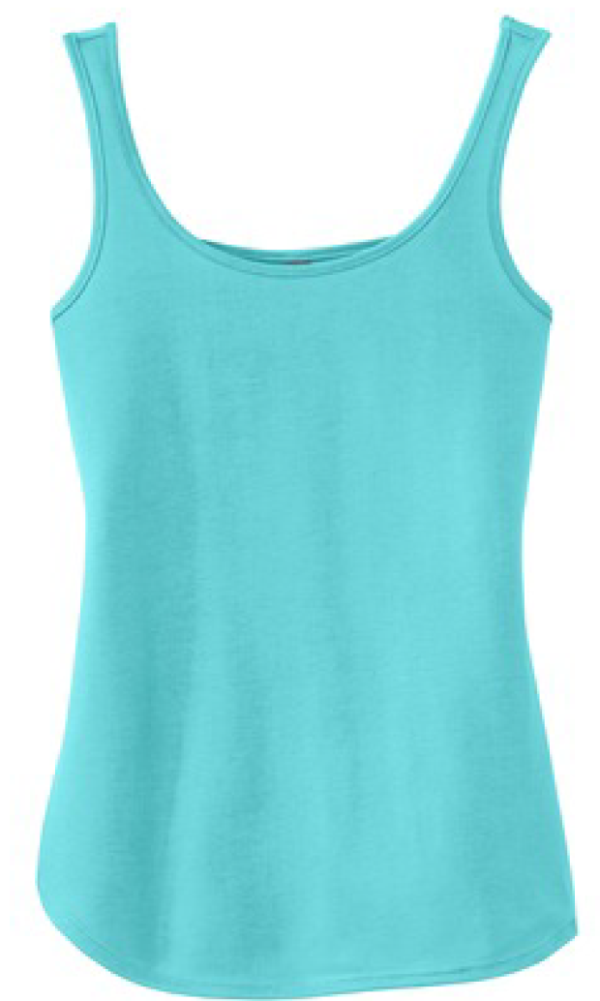 Available In: 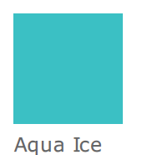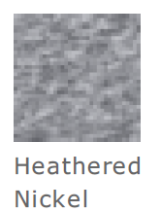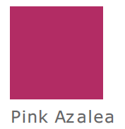
XS S M L XL XXL (add $2)
Quantity: ____ ____ ____ _____ ____ ____
Color: ____ ____ ____ _____ ____ ____
Total: ____ ____ ____ _____ ____ ____ Grand Total Drapey Tank $_____

Ladies ¼ Zip Sweatshirt/Royal Blue Logo On Chest “Pocket” $30
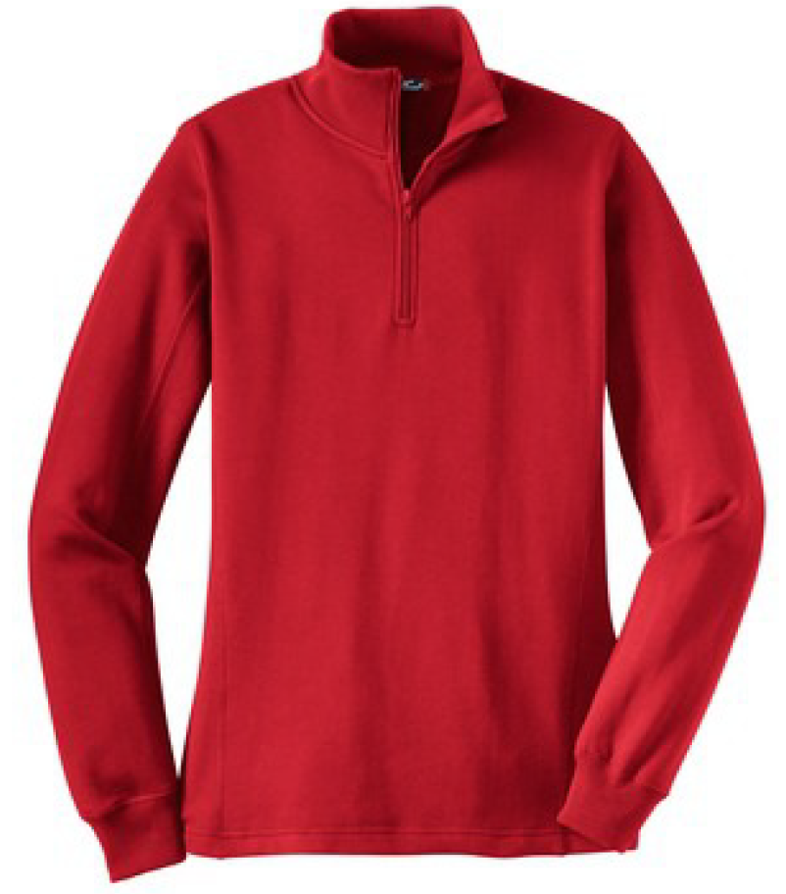Available In:
XS S M L XL XXL (add $2)
Quantity: ____ ____ ____ _____ ____ ____
Color: ____ ____ ____ _____ ____ ____
Total: ____ ____ ____ _____ ____ ____ Grand Total ¼ Zip Sweatshirt $_____

Men’s Long Sleeve Tee/Royal Blue Logo Front Center $22
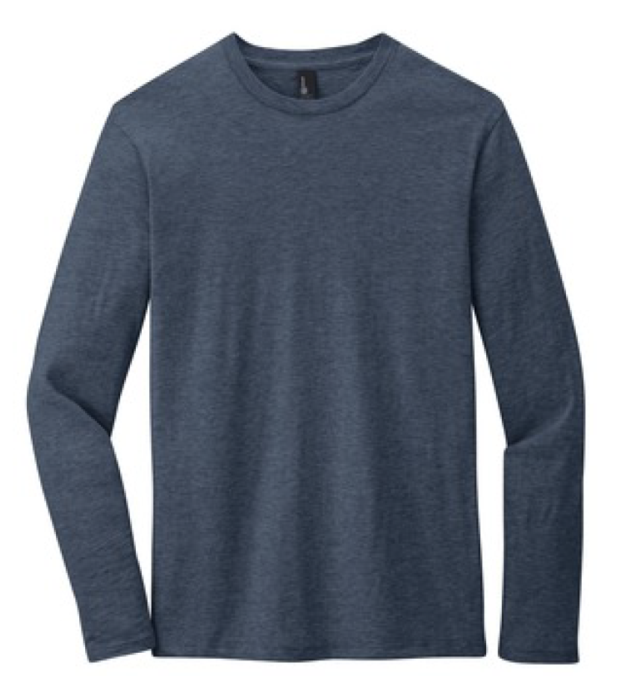Available In: 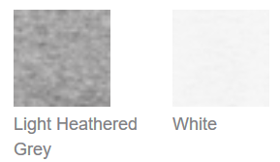
XS S M L XL XXL (add $2)
Quantity: ____ ____ ____ _____ ____ ____
Color: ____ ____ ____ _____ ____ ____
Total: ____ ____ ____ _____ ____ ____ Grand Total Men’s LS Tee $_____

Ladies Long Sleeve Tee/ Royal Blue Logo Front Center $22
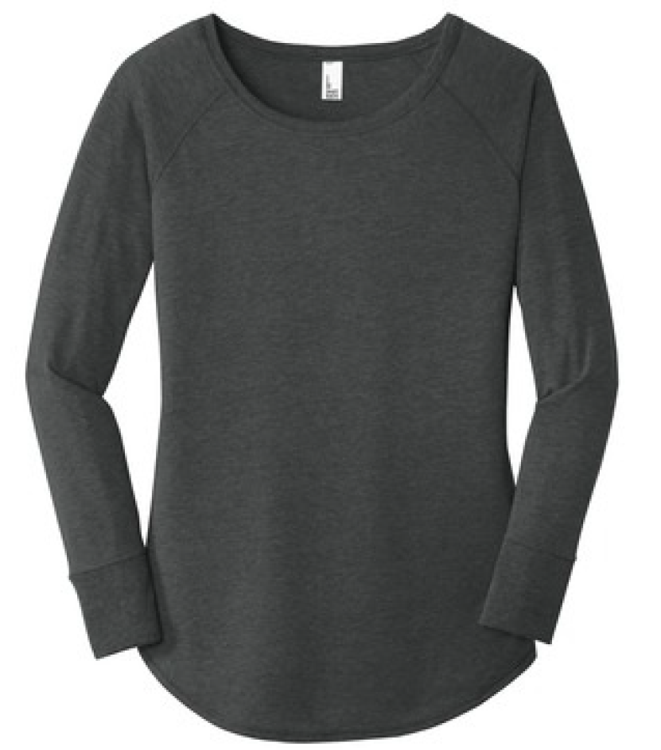 Available In:
XS S M L XL XXL (add $2)
Quantity: ____ ____ ____ _____ ____ ____
Color: ____ ____ ____ _____ ____ ____
Total: ____ ____ ____ _____ ____ ____ Grand Total Ladies LS Tee $_____

Unisex 100% Cotton Hat/Embroidered with Royal Blue “Cromwell Arts Alliance” $15
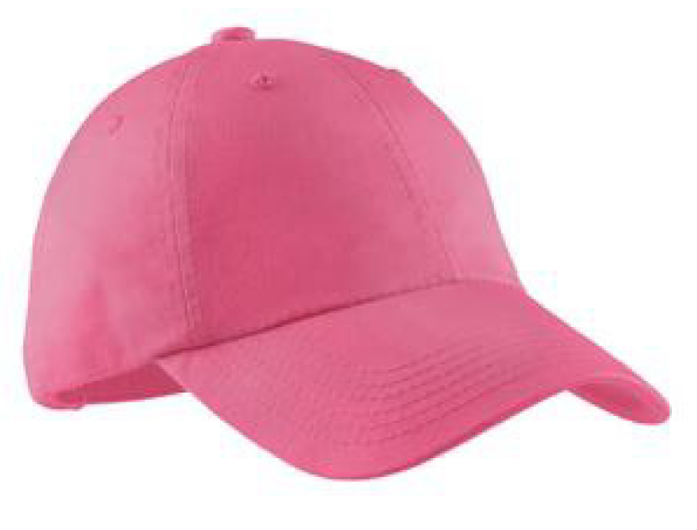Available in:
Quantity: ____ Grand Total Hat $_____
_____________________________________________________________________________________
If you would like to order, please e:mail cromwellartsalliance@gmail.com

