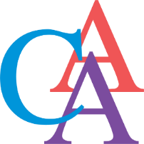
Cromwell Arts Alliance
MEETING
Monday, March 11, 2024
6:00 pm
Senior Center Dining Room (at Cromwell Town Hall)
Join virtually:
Join Zoom Meeting via your computer:
https://atlanticdatasecurity.zoom.us/j/99802619219
Password: 990451
Join Zoom Meeting via phone:
Phone number: 1 646 558-8656
Meeting ID: 998 0261 9219
Password: 990451

Meeting Agenda

- Call to order
- Approval of agenda
- Approval of minutes from the meeting on December 11, 2023 and meeting on February 12, 2024
- Public Comments
- Financial Report
- All other Business
  - CCD Report
  - Scholarship
  - Social Media/Website
- CAA Events
  - Traveling Bear Update
  - Upcoming events
- Community Events
  - Youth Services Fair
  - Upcoming events
- Public Comments – agenda items only
- Adjourn

2024 Meeting Dates:
Meetings are held on the Second Monday of the month (unless it is a holiday) at 6:00 pm. We will continue to meet in person in the Senior Center Dining Room (at Cromwell Town Hall), we will also continue to have an open zoom conference for those wishing to join virtually.
January 8- Canceled | April 8 | July 8 | * Tuesday October 15
February 12 | May 13 | August 12 | November 18**
March 11 | June 10 | September 17** | December 9
*Meeting held on Tuesday due to Holiday
** Meeting held on the third Tuesday

